Objectives:

* Creating array Lists, adding & removing items from a list, sum, and average numbers from a list.
* Creating a Tkinter using arrays and multiple forms.

Please submit this document for grading when completed… Please work in groups.

**There are 5 Challenge Exercises, each worth 20%**

Tuples are **used to store multiple items in a single variable**.

**Project #1** (creating lists). A list is a container that can hold character or number values. Instead of having to declare multiple variables, we can use one variable and assign multiple parameters.

Specifying which number in a list to print using indexes, notice the 0-index pointing to number 2.

|  |
| --- |
| Values = 2 4 6 8 10 |
| Indexes = 0 1 2 3 4 |
|  |

Sum the list of numbers using a for loop

**Project #2** (creating lists, with input values and outputting the list to a text file)

Pass the name to the list

**Project #3** (creating list box using Tkinter)

**Challenge Exercise #1: add your three favorite food items to the list box.**

**#1 Print screen the running application with the code below here.**

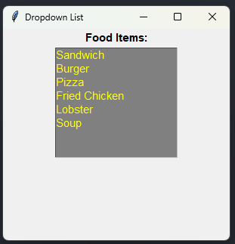

Code:

from tkinter import *

win = Tk()

win.title("Dropdown List") #Label title for window

win.geometry("300x280")

listbox = Listbox(win, height = 8, width= 20, bg = "grey", activestyle = "dotbox", font = "Helvetica 11", fg = "yellow")

label = Label(win, text = "Food Items:", font = "Arial 11 bold", justify="left")

label.pack()

listbox.insert(1, "Sandwich")

listbox.insert(2, "Burger")

listbox.insert(3, "Pizza")

listbox.insert(4, "Fried Chicken")

listbox.insert(5, "Lobster")

listbox.insert(6, "Soup")

listbox.pack()

win.mainloop()

**Project #4** (creating a list box using Tkinter and Selecting from it)

**Challenge Exercise #2:** continuing with project #3, print the food items on the console.

**#2 Print screen the running application with the code below here.**

**#2 Print screen the running application with the code below here.**

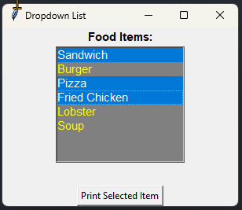

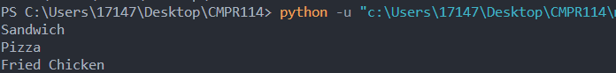

Code:

from tkinter import *

def create_window():

win = Tk()

win.title("Dropdown List") #Label title for window

win.geometry("300x320")

listbox = Listbox(win, height = 8, width= 20, bg = "grey", activestyle = "dotbox", font = "Helvetica 11", fg = "yellow", selectmode=MULTIPLE)

label = Label(win, text = "Food Items:", font = "Arial 11 bold", justify="left")

label.pack()

listbox.insert(1, "Sandwich")

listbox.insert(2, "Burger")

listbox.insert(3, "Pizza")

listbox.insert(4, "Fried Chicken")

listbox.insert(5, "Lobster")

listbox.insert(6, "Soup")

listbox.pack()

def print_list():

for i in listbox.curselection():

print(listbox.get(i))

btn = Button(win, text = "Print Selected Item", command = print_list)

btn.pack(side = "bottom")

win.mainloop()

def main():

create_window()

main()

**Project #5:** *Replacing* an old item in a list with a new item.

**Project #6:** This program will demonstrate how to insert and remove items in a list, and the total and average number of items in a list.

**Challenge Exercise #3:** continuing with project #6, the total function, output the numbers list to a text file.

**#3 Print screen the running application with the code below here.**



Code:

def total():

numbers = [1,2,3,4,5,6,7,8,9,10]

sum = 0

for num in numbers:

sum+=num

average = sum / len(numbers)

print(f"The total is {sum} and the average is {average:,.2f}")

file = open("C:\\Users\\17147\\Desktop\\CMPR114\\m3\\numbers.txt", "w")

file.write(" ".join(str(e) for e in numbers) + "\n")

file.write(f"The total is {sum} and the average is {average:,.2f}")

file.close

total()

**Challenge Exercise #4:** TOTAL SALES APP: Design a program that asks the user to enter a store’s sales for each day of the week. The amount should be stored on a list. Use a loop to calculate the total sales for the week and display the result. Plus output the results into a text file as well as the console.

**#4 Print screen the running application with the code below here.**

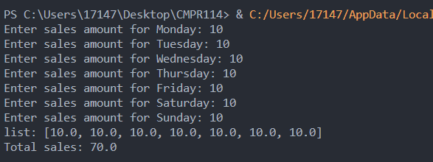

Code:

week = ["Monday","Tuesday","Wednesday","Thursday","Friday","Saturday","Sunday"]

sales = []

total = 0

for day in week:

salesamt = float(input(f"Enter sales amount for {day}: "))

total+=salesamt

sales.append(salesamt)

print(f"list: {sales}")

msg = f"Total sales: {total}\n"

print(msg)

file = open("C:\\Users\\17147\\Desktop\\CMPR114\\m4\\Sales.txt", "w")

file.write(msg)

file.close

**Project #7**

**Using Tkinter with arrays and using multiple forms.**

**Challenge Exercise #5:** Continuing with project #7, create the *zip code*, and *age* entries, and then output the contents to a text file somewhere on your computer.

**#5 Print screen the running application with the code below here with the OPEN text file. (Be sure to enter 2 entries).**

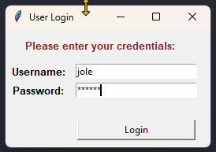

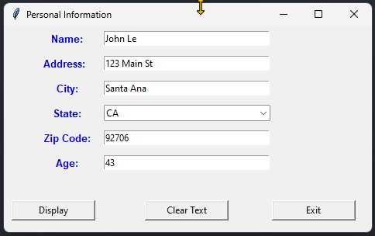

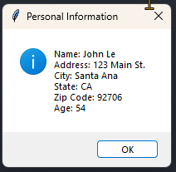

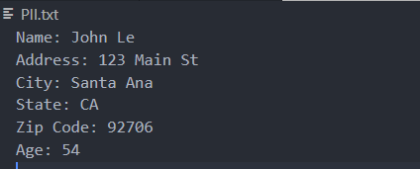

Code:

import tkinter as tk

from tkinter import ttk

from tkinter import messagebox

def main():

def login_user():

username = txtUserName.get()

password = txtPassword.get()

if username == "jole" and password == "pwd123":

#messagebox.showinfo(title="Welcome", message="Successful login.")

entry_win.deiconify()

login_win.withdraw()

else:

messagebox.showerror(title="Invalid login", message="Username or Password is not correct. Try again")

txtUserName.delete(0, tk.END)

txtPassword.delete(0, tk.END)

txtUserName.focus_set()

def display_data():

name = txtName.get()

address = txtAddress.get()

city = txtCity.get()

state = cmbState.get()

zipcode = txtZipcode.get()

age = txtAge.get()

msg = f"Name: {name}\nAddress: {address}\nCity: {city}\nState: {state}\nZip Code: {zipcode}\nAge: {age}\n"

messagebox.showinfo(title="Personal Information", message=msg)

#Write to file

file = open("C:\\Users\\17147\\Desktop\\CMPR114\\m4\\PII.txt", "w")

file.write(msg)

file.close

def clear_textbox():

txtName.delete(0, tk.END)

txtAddress.delete(0, tk.END)

txtCity.delete(0, tk.END)

cmbState.set("")

txtZipcode.delete(0, tk.END)

txtAge.delete(0, tk.END)

def exit_win():

entry_win.quit()

entry_win.destroy()

login_win.quit()

login_win.destroy()

#Set State dropdown values

states = ['AK','AL','AR','AZ','CA','CO','CT','CZ','DC','DE','FL','GA','GU','HI','IA','ID',

'IL','IN','KS','KY','LA','MA','MD','ME','MI','MN','MO','MS','MT','NC','ND','NE',

'NH','NJ','NM','NV','NY','OH','OK','OR','PA','PR','RI','SC','SD','TN','TX','UT',

'VA','VI','VT','WA','WI','WV','WY']

#Login Window

login_win = tk.Tk()

login_win.geometry("260x150")

login_win.title("User Login")

lblHeader = tk.Label(login_win, text="Please enter your credentials: ", font="Arial 10 bold", fg="#8B2323", justify="center")

lblHeader.grid(row=0, column=0, pady=10, columnspan=3)

lblUserName = tk.Label(login_win, text="Username: ", font="Arial 10 bold", width=10)

lblUserName.grid(row=1, column=0, padx=1, pady=1)

#lblUserName.pack()

txtUserName = tk.Entry(login_win, width=25)

txtUserName.grid(row=1, column=1, padx=1, pady=1)

#txtUserName.pack()

lblPassword = tk.Label(login_win, text="Password: ", font="Arial 10 bold")

lblPassword.grid(row=2, column=0, padx=1, pady=1)

#lblPassword.pack()

txtPassword = tk.Entry(login_win, width=25, show="*")

txtPassword.grid(row=2, column=1, padx=1, pady=1)

#txtPassword.pack()

lblSpace = tk.Label(login_win, text=" ", font="Arial 10 bold")

lblSpace.grid(row=3, column=0, padx=1, pady=1)

btnSubmit = tk.Button(login_win, text="Login", command=login_user, width=20)

btnSubmit.grid(row=4, column=1, padx=1, pady=1)

#Personal Data Entry Window

entry_win = tk.Tk()

entry_win.geometry("475x265")

entry_win.title("Personal Information")

entry_win.withdraw()

lblName = tk.Label(entry_win, text="Name: ", font="Arial 10 bold", fg="#0000CD", width=10)

lblName.grid(row=0, column=0, padx=1, pady=5, sticky="ne")

txtName = tk.Entry(entry_win, width=35)

txtName.grid(row=0, column=1, padx=0, pady=5)

txtName.focus_set()

lblAddress = tk.Label(entry_win, text="Address: ", font="Arial 10 bold", fg="#0000CD", width=10)

lblAddress.grid(row=1, column=0, padx=5, pady=5, sticky="ne")

txtAddress = tk.Entry(entry_win, width=35)

txtAddress.grid(row=1, column=1, padx=1, pady=5)

lblCity = tk.Label(entry_win, text="City: ", font="Arial 10 bold", fg="#0000CD", width=10)

lblCity.grid(row=2, column=0, padx=1, pady=5, sticky="ne")

txtCity = tk.Entry(entry_win, width=35)

txtCity.grid(row=2, column=1, padx=1, pady=5)

lblState = tk.Label(entry_win, text="State: ", font="Arial 10 bold", fg="#0000CD", width=10)

lblState.grid(row=3, column=0, padx=1, pady=5, sticky="ne")

cmbState = ttk.Combobox(entry_win, width=32, values=states)

cmbState.grid(row=3, column=1, padx=1, pady=5)

lblZipcode = tk.Label(entry_win, text="Zip Code: ", font="Arial 10 bold", fg="#0000CD", width=10)

lblZipcode.grid(row=4, column=0, padx=1, pady=5, sticky="ne")

txtZipcode = tk.Entry(entry_win, width=35)

txtZipcode.grid(row=4, column=1, padx=1, pady=5)

lblAge = tk.Label(entry_win, text="Age: ", font="Arial 10 bold", fg="#0000CD", width=10)

lblAge.grid(row=5, column=0, padx=1, pady=5, sticky="ne")

txtAge = tk.Entry(entry_win, width=35)

txtAge.grid(row=5, column=1, padx=1, pady=5)

lblSpace1 = tk.Label(entry_win, text=" ")

lblSpace1.grid(row=6, column=0, padx=1, pady=5, sticky="ne")

btnSubmit = tk.Button(entry_win, text="Display", command=display_data, width=14)

btnSubmit.grid(row=7, column=0, padx=10, pady=1)

btnClear = tk.Button(entry_win, text="Clear Text", command=clear_textbox, width=14)

btnClear.grid(row=7, column=1, padx=1, pady=1)

btnExit = tk.Button(entry_win, text="Exit", command=exit_win, width=14)

btnExit.grid(row=7, column=2, padx=1, pady=1)

login_win.mainloop()

main()

**Submit this document to Module 4 Class Exercise.**